Project Development Phase
Model Performance Test

Date | 17th July, 2025
Team ID | LTVIP2025TMID56158
Project Name | TrafficTelligence: Advanced Traffic Volume Estimation with Machine Learning
Maximum Marks | 10 Marks

Model Performance Testing:
Project team shall fill the following information in model performance testing template.
S.No. | Parameter | Values | Screenshot
 | Metrics | Regression Model:  MAE - , MSE - , RMSE - , R2 score - | 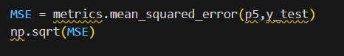  798.2812004550777
 | Tune the Model | Hyperparameter Tuning – Used XGBoost | 